Lab 01: Containers and Logging Concept

Scenario
You are a security analyst working with Kali Linux and need to test a new vulnerability scanner. Given the critical nature of the testing, it was essential to isolate the scanner’s environment to prevent any potential impact on the host system. To achieve this, Docker was utilized to create a secure, isolated container specifically for the scanner and its dependencies. This containerized setup ensured a contained environment that mitigated risks of system-wide effects, allowing the analyst to proceed confidently with the testing.

Business Challenge
The primary challenge arose when the scanner, operating within the Docker container, exhibited performance issues that hindered its efficiency. This introduced delays in the vulnerability assessment process, presenting a potential barrier to timely analysis and impacting the overall productivity of the security workflow. Identifying the root cause of these performance problems was critical to ensuring a smooth and effective testing process within the confined environment of the container, which was essential for safeguarding the host system from unintentional impact.

Solution
To address the issue, you first ensure that Docker is properly installed on your Kali Linux system. After launching the vulnerability scanner within its Docker container, you need to troubleshoot by examining the logs.
1. Install docker
2. Install and check the operating system
1. Open your Kali Linux terminal and install docker by using the command sudo apt install docker.io.
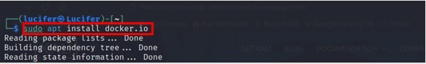
2. Install any desired operating system image you want by using the command sudo docker pull <image:file>.
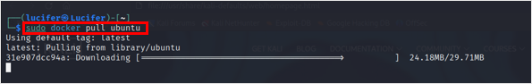
3. Give a name to the Operating system image file. Use the command sudo docker –d –t –name <name of image> <osname>.
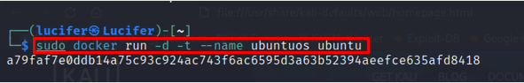
4. Use the command command sudo docker ps. To see which Operating system is running.
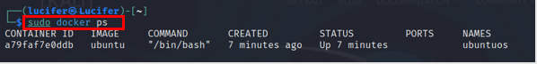
5. Run the Ubuntu container. For that, use the command sudo docker exec –it ubuntuos /bin/bash. After running this command, the prompt changes to root@a79faf7e0ddb:/#, indicating that you are now operating inside the ubuntuos container, with root (administrator) access.
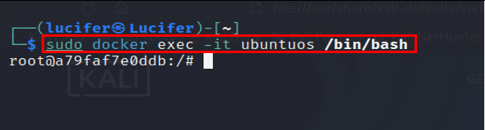
6. Now, you can execute ls command within the container, which lists the contents of the root (/) directory in the container’s file system.
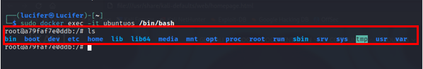

Lab 02: Linux Logging and Auditing Capabilities

Scenario
A company’s Kali Linux server has been behaving unusually, with frequent spikes in resource usage and suspected unauthorized access attempts. The system administrator notices that certain critical files, such as /etc/passwd, may have been modified without proper authorization. Moreover, the logs appear to be incomplete, with significant gaps during key time periods when the unusual behavior was observed. The organization is concerned about potential security breaches and needs a reliable way to track file access, monitor system activities, and ensure that log files are well-maintained for future auditing and troubleshooting.

Business Challenge
The main challenge for the organization was maintaining an effective and comprehensive system monitoring setup. With unusual resource consumption patterns and gaps in logging data, they struggled to piece together what may have caused these irregularities and could not verify if unauthorized access attempts had been made successfully. Incomplete logs not only hampered the company’s ability to perform effective incident response and forensics but also posed a risk to ongoing operations, as they lacked real-time visibility into potential security events. To protect critical assets and maintain a secure operating environment, the organization needed a systematic approach to enhance file integrity monitoring, improve log retention, and ensure a resilient and auditable record of system activity.

Solution
To address these issues, the administrator first improves the system’s logging capabilities by ensuring that logs are properly configured and maintained. They configure the logging system to capture detailed information about system processes, authentication attempts, and any errors that may have occurred. A robust log rotation policy is implemented to ensure that log files are regularly archived, compressed, and easily retrievable without consuming too much disk space. This helps the administrator have a consistent record of system activities and allows for easier analysis during troubleshooting.
1. Install rsyslog for logging check
2. Install the auditing package
1. Open your Kali Linux machine and install rsyslog by using the command sudo apt install rsyslog.
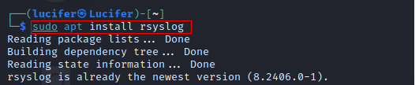
2. Use commands to start the rsyslog. sudo systemctl start rsyslog and use command
sudo systemctl enable rsyslog to enable it.
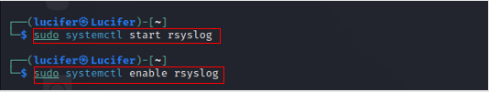
3. To check the status of rsyslog. use the command sudo systemctl status rsyslog.
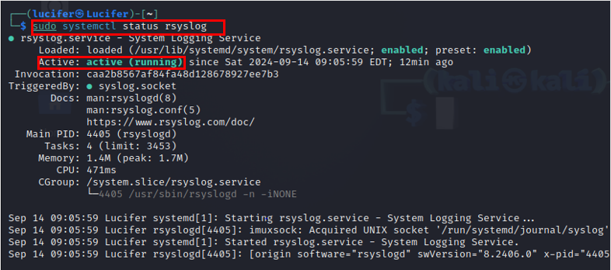
4. Now, install the auditing package on your machine using the command sudo apt install auditd.
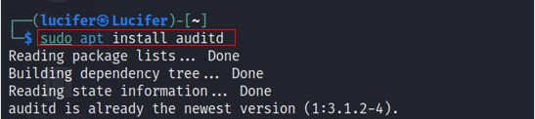
5. Confirm whether it is installed successfully or not by using the command sudo auditctl –l.
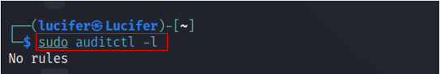
6. Check that someone is altering a file or directory. By using the command sudo auditctl -w /etc/passwd -p rwxa.
-w flag , > Inserts a watch for a filesystem object in the path.
-p flag , -> This defines the type of permission access to the filesystem.
rwxa , -> These are the read, write, and execute attributes that are bonded to the -p flag.
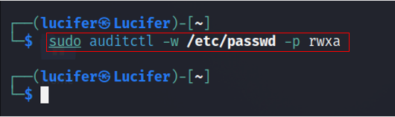
7. Now, create a sample directory by the name of tempdir for the purpose of auditing it. Use the command sudo auditctl –w /tempdir/.
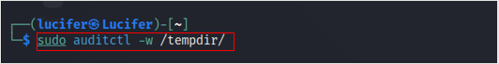
8. Run the command sudo aduitctl –l again to check the dicrectory.
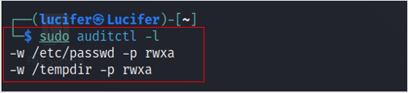
9. To see the audit logs of the tempdir, the audit log files are stored in the /var/log/audit/audit.log path. Use the command sudo tail -f /var/log/syslog.
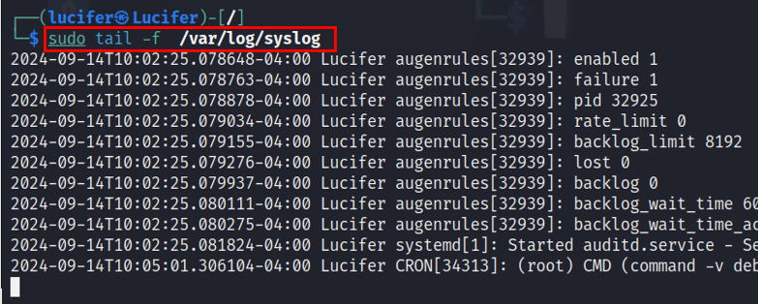
10. Use the command sudo tail –f /var/log/audit/audit.log to see real-time auditing.
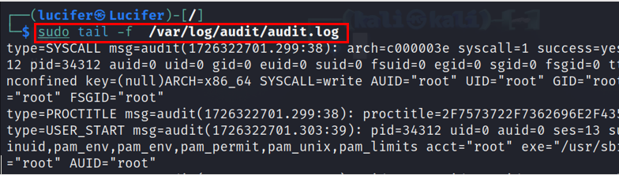
11. Now, generate an audit report by using the command aureport.
